# Enhancing a script using Selenium IDE

# Verify Presence of an element: We can use following two commands to verify the presence of an element.

* **verifyElementPresent:** returns TRUE if the specified element was FOUND in the page; FALSE if otherwise.
* **verifyElementNotPresent:** returns TRUE if the specified element was NOT FOUND anywhere in the page; FALSE if it is present.

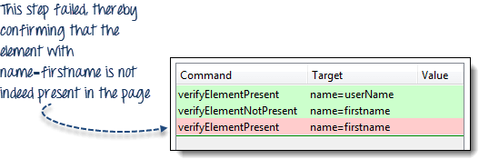

* **Verify Presence of a Certain Text:**
* **verifyTextPresent:**  returns TRUE if the specified text string was FOUND somewhere in the page; FALSE if otherwise.
* **verifyTextNotPresent:**  returns TRUE if the specified text string was NOT FOUND anywhere in the page; FALSE if it was found.

Remember that these commands are **case-sensitive.**

* **Verify Specific Position of an Element:** Selenium IDE indicates the position of an element by measuring (in pixels) how far it is from the left or top edge of the browser window.
* **verifyElementPositionLeft** - verifies if the specified number of pixels match the distance of the element from the left edge of the page..
* **verifyElementPositionTop** - verifies if the specified number of pixels match the distance of the element from the top edge of the page.

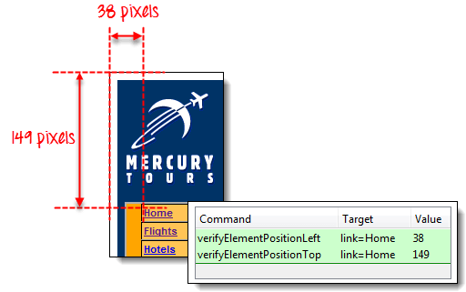

**Wait Commands**

* **andWait commands:** These are commands that will wait for a new page to load before moving onto the next command. Examples are:
* clickAndWait
* typeAndWait
* selectAndWait

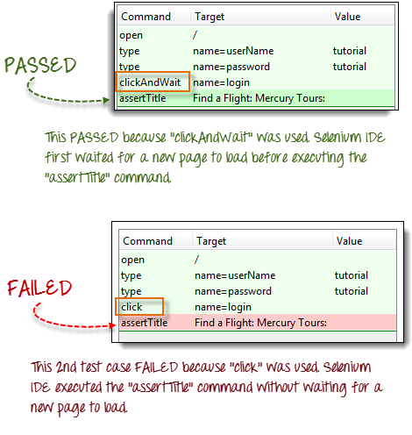

**waitFor Commands**

These are commands that wait for a specified condition to become true before proceeding to the next command (irrespective of loading of a new page). These commands are more appropriate to be used on AJAX-based dynamic websites that change values and elements without reloading the whole page. Examples include:

* waitForTitle
* waitForTextPresent
* waitForAlert

Consider the Facebook scenario below:

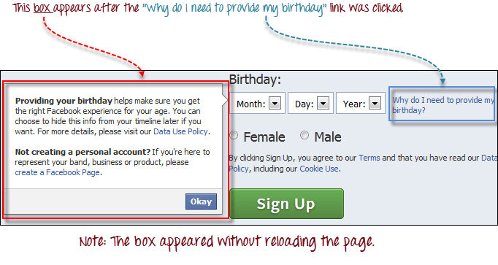

We can use a combination of "click" and "waitForTextPresent" to verify the presence of the text "Providing your birthday."

[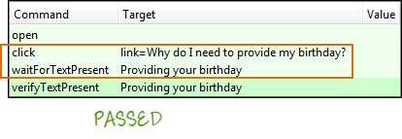](https://www.guru99.com/images/image008.png)

We cannot use clickAndWait because no page was loaded upon clicking on the "Why do I need to provide my birthday?" link. If we do, the test will fail

[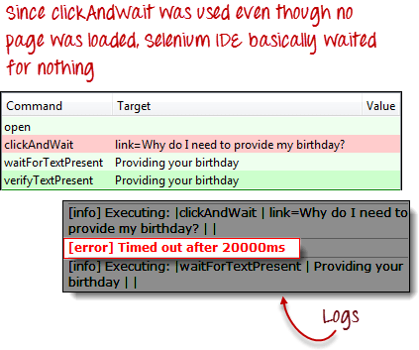](https://www.guru99.com/images/image009.png)